EX NO: 3a | GENERATION OF PHASE MODULATED (PM) SIGNALS AND CALCULATION OF PHASE DEVIATION USING MATLAB SIMULATION
DATE:

Objectives:

i) To generate a Phase Modulated (PM) signal in MATLAB using specified carrier and message signal parameters.

ii) To observe and analyze the time-domain characteristics of the message signal, carrier signal, and phase modulated signal through MATLAB simulation.

iii) To calculate the phase deviation of the PM signal using the phase sensitivity constant and message signal amplitude.

iv) To determine the modulation index of the PM signal and examine its relationship with phase deviation.

v) To investigate the effect of varying message signal amplitude on the phase deviation and modulation characteristics of the PM signal.

vi) To compare PM waveforms obtained for different phase deviation values and analyze their modulation behavior using MATLAB.

PROGRAM (MATLAB CODE)
clc;
clear;
close all;
% Parameters
Am = 1; % Message Amplitude (V)
fm = 100; % Message Frequency (Hz)
Ac = 5; % Carrier Amplitude (V)
fc = 1000; % Carrier Frequency (Hz)
fs = 20*fc; % Sampling Frequency (Hz)
kp = pi/2; % Phase Sensitivity (rad/V)
% Time Vector
t = 0:1/fs:4/fm;
% Message Signal
m = Am*sin(2*pi*fm*t);
% Carrier Signal
c = Ac*cos(2*pi*fc*t);
% Phase Modulated Signal
pm = Ac*cos(2*pi*fc*t + kp*m);
% Phase Deviation
phase_dev = kp*Am;
% PM Modulation Index
mp = phase_dev;
% Display Results
fprintf('Message Amplitude = %.2f V\n',Am);
fprintf('Message Frequency = %.0f Hz\n',fm);
fprintf('Carrier Amplitude = %.2f V\n',Ac);
fprintf('Carrier Frequency = %.0f Hz\n',fc);
fprintf('Phase Sensitivity = %.2f rad/V\n',kp);
fprintf('Phase Deviation = %.2f radians\n',phase_dev);
fprintf('PM Modulation Index = %.2f\n',mp);
% Plotting
figure('Name','Phase Modulation and Phase Deviation',...
'NumberTitle','off');
subplot(2,2,1);
plot(t,m,'LineWidth',1.5);
title('Message Signal');
xlabel('Time (s)');
ylabel('Amplitude');
grid on;
subplot(2,2,2);
plot(t,c,'LineWidth',1.5);
title('Carrier Signal');
xlabel('Time (s)');
ylabel('Amplitude');
grid on;
subplot(2,2,3);
plot(t,pm,'LineWidth',1.5);
title('Phase Modulated Signal');
xlabel('Time (s)');
ylabel('Amplitude');
grid on;
subplot(2,2,4);
bar(phase_dev);
title('Phase Deviation');
ylabel('Radians');
set(gca,'XTickLabel',{'PM Signal'});
grid on;

Procedure:
- Open MATLAB and create a new script file.
- Initialize the MATLAB workspace by clearing all variables, command window contents, and open figure windows using:
MATLABclc; clear; close all;
- Define the message signal amplitude ( ), message frequency ( ), carrier amplitude ( ), carrier frequency ( ), sampling frequency ( ), and phase sensitivity constant ( ).
- Generate the time vector required for simulation using the specified sampling frequency.
- Generate the message signal using a sinusoidal waveform with frequency .
- Generate the carrier signal using a sinusoidal waveform with frequency .
- Generate the Phase Modulated (PM) signal
- Plot the message signal, carrier signal, and phase modulated signal using MATLAB plotting commands.
- Observe the phase variations in the PM waveform corresponding to changes in the message signal amplitude.
- Calculate the phase deviation of the PM signal
- Determine the PM modulation index from the calculated phase deviation.
- Display the values of phase deviation and modulation index in the MATLAB Command Window using the fprintf() function.
- Repeat the simulation for different message signal amplitudes and observe the corresponding change in phase deviation.
- Compare the generated PM waveforms for different phase deviation values.
- Record the observations and verify the relationship between message amplitude, phase deviation, and modulation index.
- Analyze the simulation results and validate the characteristics of Phase Modulation.

OUTPUT (GRAPH)
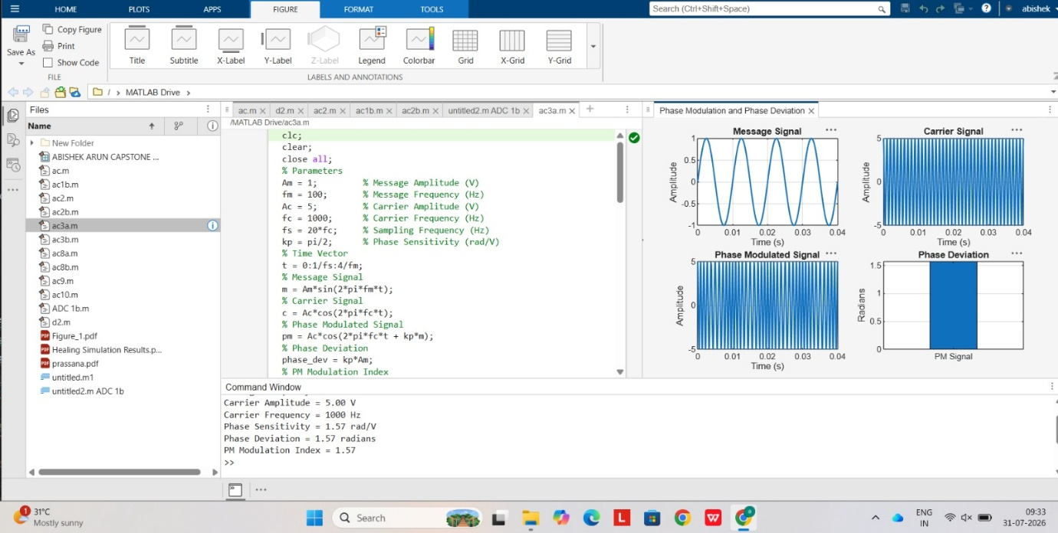

Example: (just for Understanding)
Calculations for Phase Deviation and Power Spectral Density of PM Signal
Given:
· Message Amplitude, V
· Message Frequency, Hz
· Carrier Amplitude, V
· Carrier Frequency, Hz
· Phase Sensitivity, rad/V = 1.57 rad/V

1. Phase Deviation
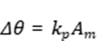

Substituting the values,
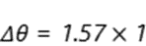
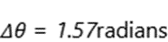

2. Modulation Index of PM Signal
For Phase Modulation,
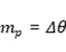
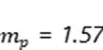

3. Estimated Bandwidth using Carson's Rule
For PM,
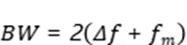
where
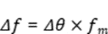
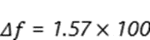
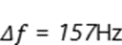
Therefore,
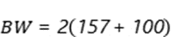
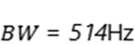

4. Carrier Power
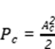
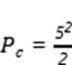
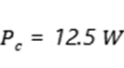

RESULT
The Phase Modulated (PM) signal was successfully generated and analyzed using MATLAB. The phase deviation was calculated from the phase sensitivity constant and message amplitude.
i) Message Frequency = 100 Hz
ii) Carrier Frequency = 1000 Hz
iii) Phase Sensitivity = 1.57 rad/V
iv) Phase Deviation = 1.57 radians
v) PM Modulation Index = 1.57
vi) The PM waveform exhibited phase variations proportional to the message signal amplitude, verifying the characteristics of Phase Modulation.

EX NO: 3b | POWER SPECTRAL DENSITY (PSD) ANALYSIS OF PHASE MODULATED (PM) SIGNALS USING MATLAB
DATE:

Objectives
i) To generate a Phase Modulated (PM) signal in MATLAB using specified carrier and message signal parameters.
ii) To compute the frequency spectrum of the PM signal using the Fast Fourier Transform (FFT).
iii) To calculate and plot the Power Spectral Density (PSD) of the PM signal using MATLAB.
iv) To identify the carrier component and sideband frequencies present in the PM spectrum.
v) To analyze the effect of phase modulation on the spectral distribution and bandwidth of the transmitted signal.
vi)To investigate the influence of modulation index on the Power Spectral Density characteristics of the PM signal.
PROGRAM (MATLAB CODE)
clc;
clear;
close all;
% Parameters
Am = 1; % Message Amplitude (V)
fm = 100; % Message Frequency (Hz)
Ac = 5; % Carrier Amplitude (V)
fc = 1000; % Carrier Frequency (Hz)
fs = 20*fc; % Sampling Frequency (Hz)
kp = pi/2; % Phase Sensitivity (rad/V)
% Time Vector
t = 0:1/fs:4/fm;
% Message Signal
m = Am*sin(2*pi*fm*t);
% PM Signal
pm = Ac*cos(2*pi*fc*t + kp*m);
% Phase Deviation
beta = kp*Am;
% FFT
N = length(pm);
f = linspace(-fs/2,fs/2,N);
PM_FFT = abs(fftshift(fft(pm)))/N;
% Power Spectral Density
PSD = (abs(fftshift(fft(pm))).^2)/(N*fs);
% Approximate Bandwidth
BW = 2*(beta+1)*fm;
fprintf('Phase Deviation = %.2f radians\n',beta);
fprintf('Estimated Bandwidth = %.2f Hz\n',BW);
% Plotting
figure('Name','PSD Analysis of PM Signal','NumberTitle','off');
subplot(2,2,1);
plot(t,m);
title('Message Signal');
xlabel('Time (s)');
ylabel('Amplitude');
grid on;
subplot(2,2,2);
plot(t,pm);
title('Phase Modulated Signal');
xlabel('Time (s)');
ylabel('Amplitude');
grid on;
subplot(2,2,3);
plot(f,PM_FFT);
title('Frequency Spectrum of PM Signal');
xlabel('Frequency (Hz)');
ylabel('Magnitude');
grid on;
subplot(2,2,4);
plot(f,PSD);
title('Power Spectral Density');
xlabel('Frequency (Hz)');
ylabel('PSD');
grid on;
Procedure:
- Open MATLAB and create a new script file.
- Initialize the MATLAB workspace by clearing all variables, command window contents, and open figure windows using:
clc; clear; close all;
- Define the message signal amplitude (AmA_mAm​), message frequency (fmf_mfm​), carrier amplitude (AcA_cAc​), carrier frequency (fcf_cfc​), sampling frequency (fsf_sfs​), and phase sensitivity constant (kpk_pkp​).
- Generate the time vector required for simulation.
- Generate the message signal and carrier signal.
- Generate the Phase Modulated (PM) signal using the PM equation.
- Compute the Fast Fourier Transform (FFT) of the PM signal.
- Calculate the Power Spectral Density (PSD) from the FFT results.
- Generate the frequency axis corresponding to the FFT output.
- Plot the message signal, PM signal, frequency spectrum, and PSD using MATLAB plotting commands.
- Determine the carrier frequency component and sideband frequencies from the spectrum.
- Display the phase deviation and estimated bandwidth using the MATLAB Command Window.
- Analyze the PSD plot and observe the spectral distribution around the carrier frequency.
- Record the observations and verify the characteristics of Phase Modulation in the frequency domain.
OUTPUT (GRAPH)
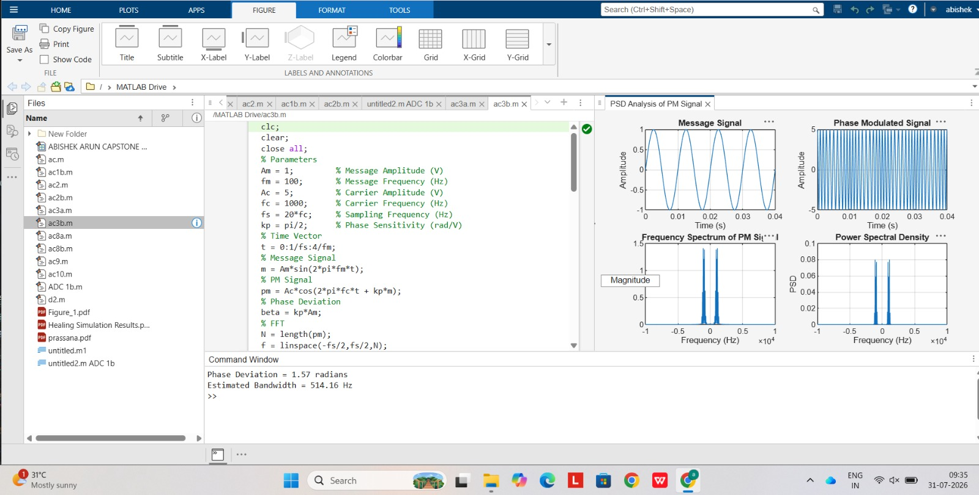

Example: (just for Understanding)
Given
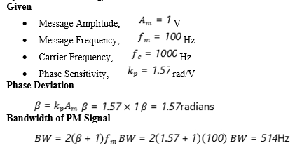
·

RESULT
The Power Spectral Density (PSD) of the Phase Modulated (PM) signal was successfully obtained and analyzed using MATLAB.
i) Message Frequency = 100 Hz
ii) Carrier Frequency = 1000 Hz
iii) Phase Deviation = 1.57 radians
iv) PM Modulation Index = 1.57
v) Estimated Bandwidth = 514 Hz
vi) The PSD plot showed the carrier component and multiple sidebands around the carrier frequency, confirming the frequency-domain characteristics of Phase Modulation.

